**NNFL EXPT-3**

**Fuzzy Controller for Avoiding obstacles**

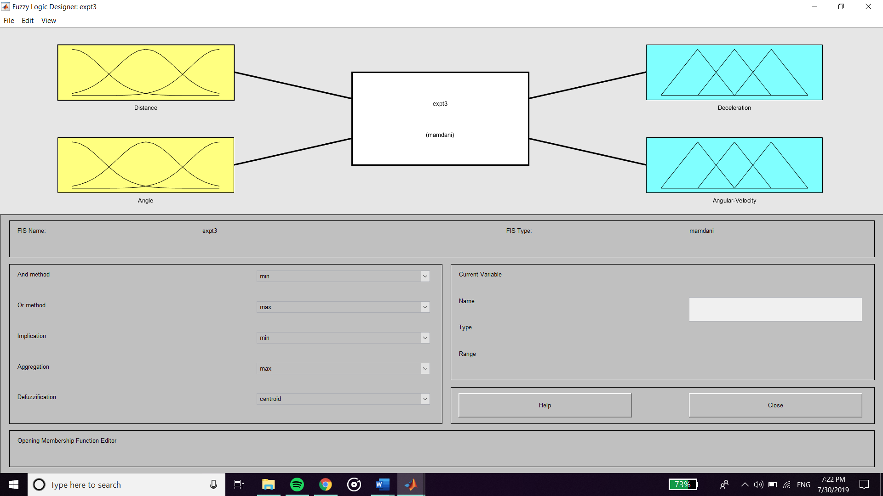

**Inputs :**

**Membership Function of Distance from obstacle**

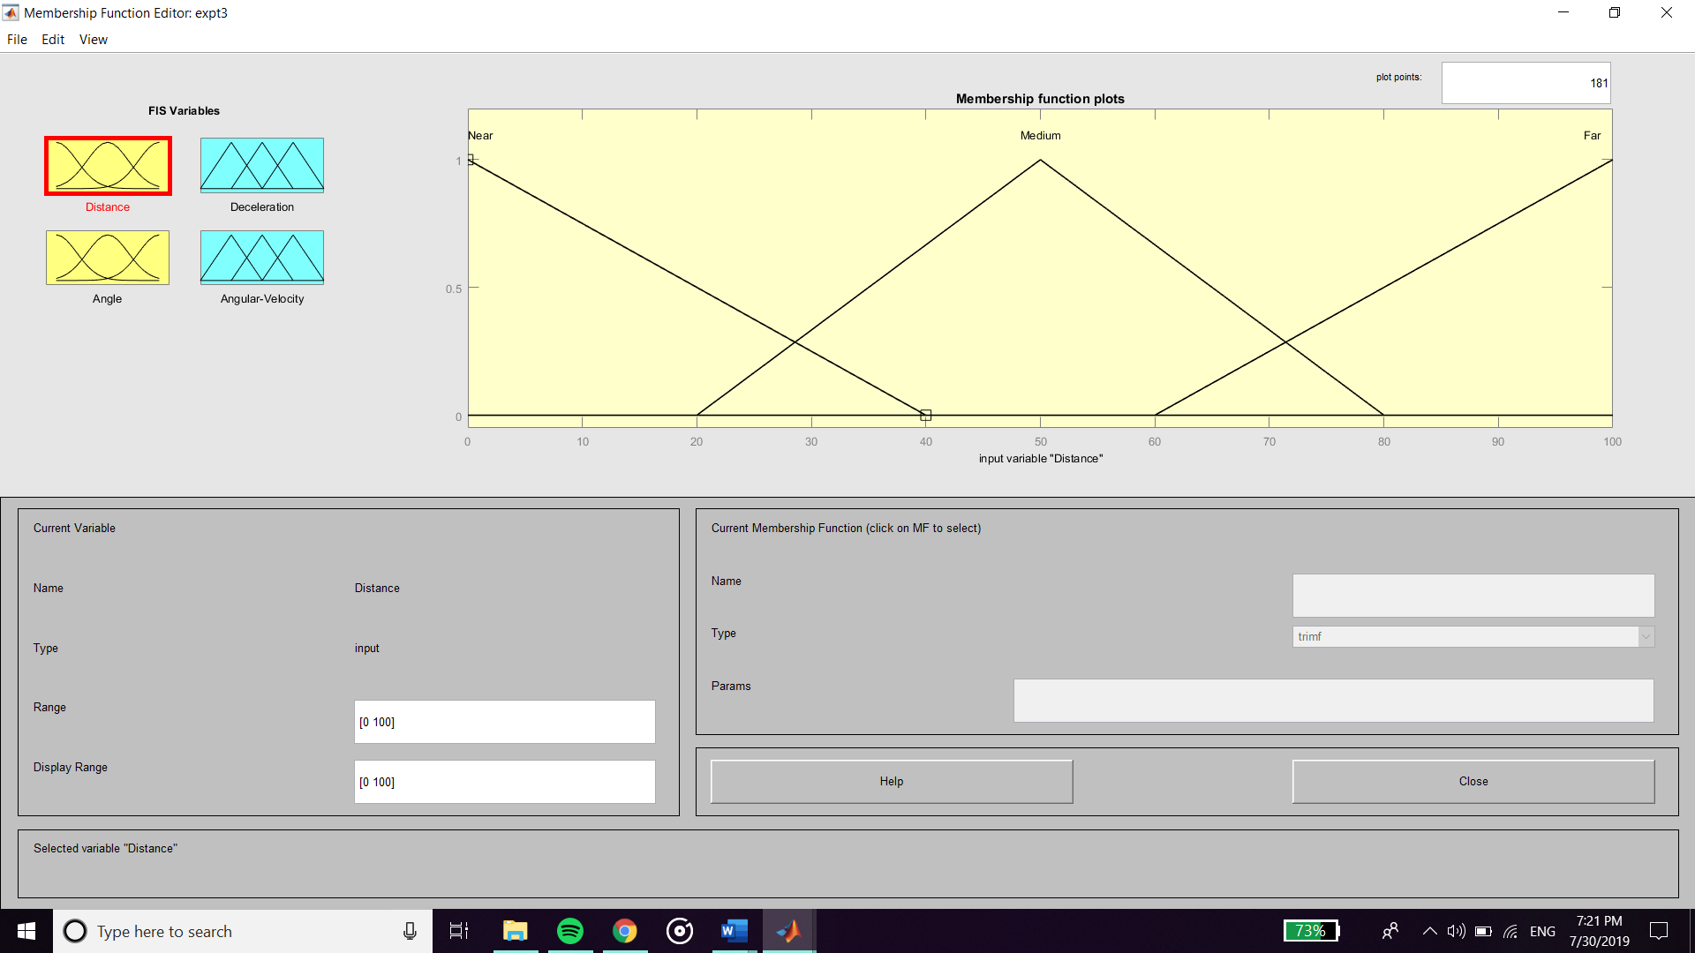

**Membership Function of Sensor angle**

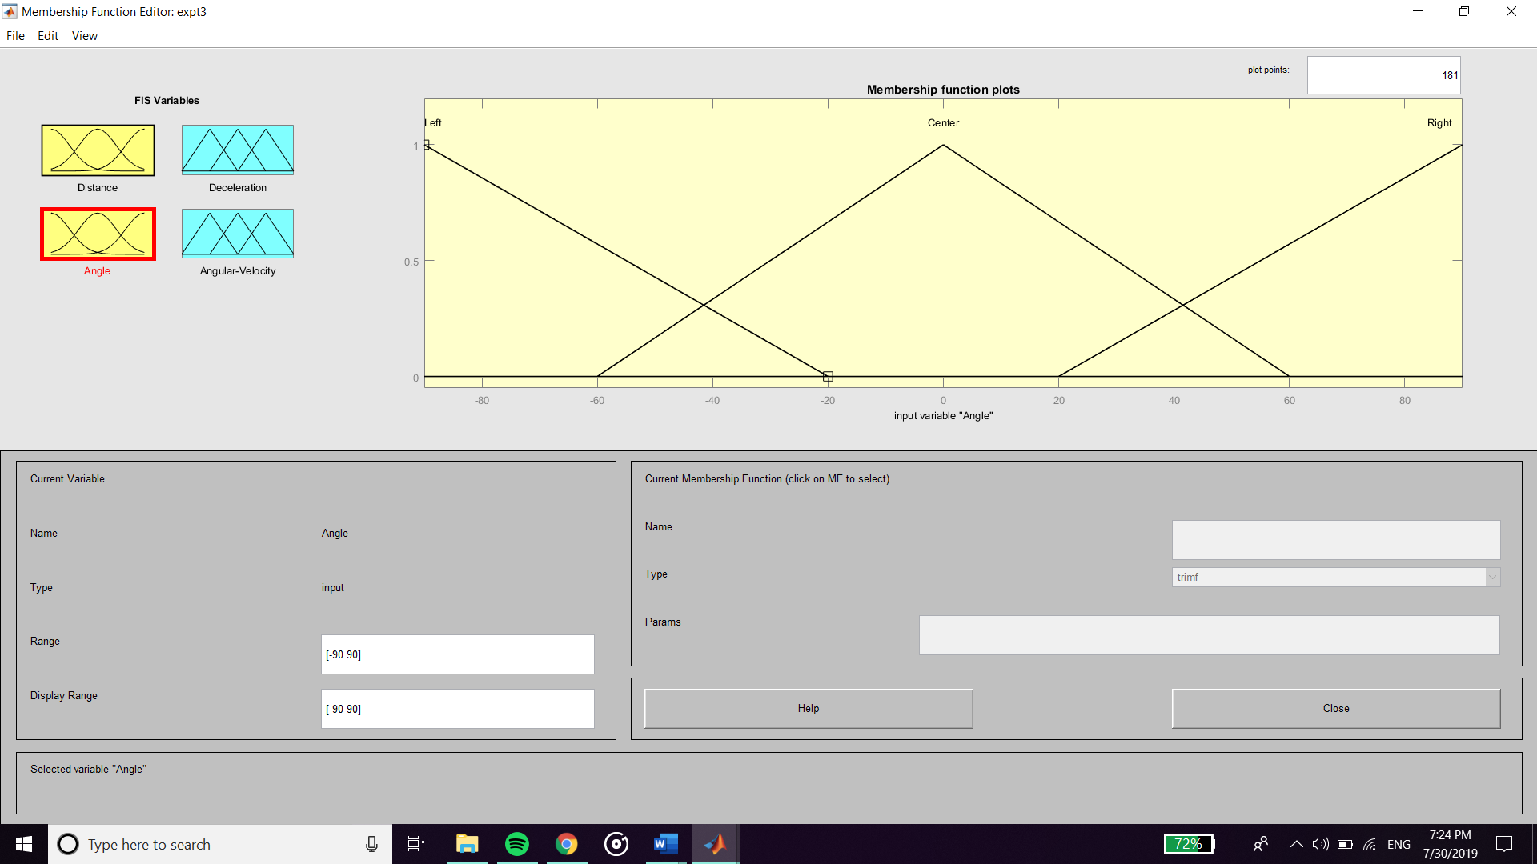

**Output :**

**Membership Function of Deceleration**

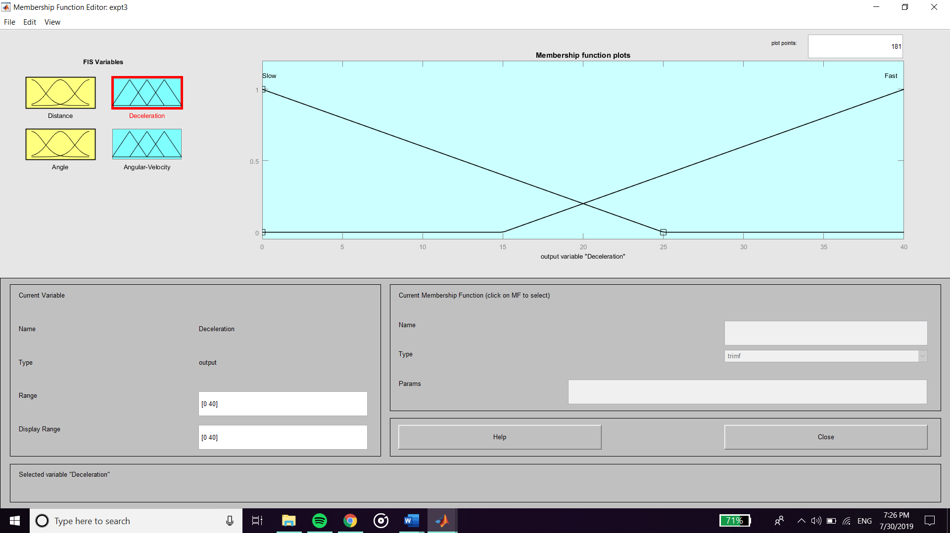

**Membership Function of Angular Velocity**

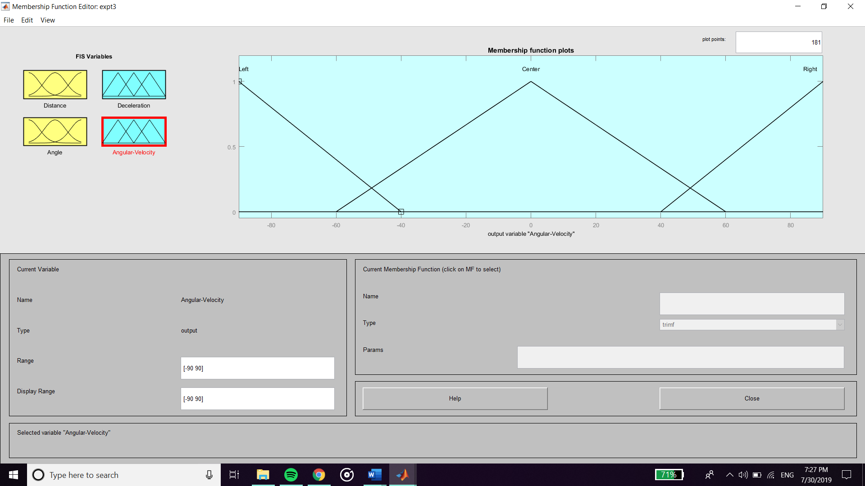

**Rules**

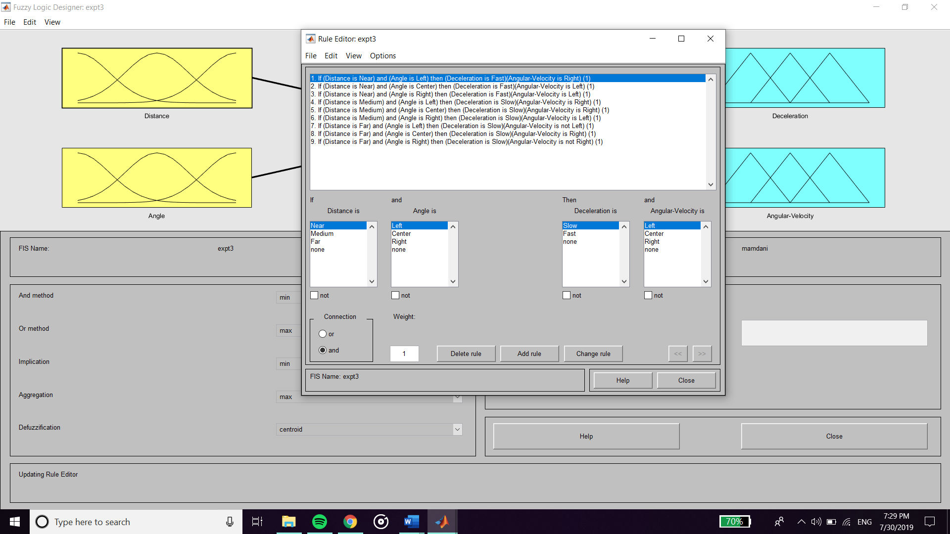

**Output :**

**For Near obstacle and sensed at Right side of the vehicle**

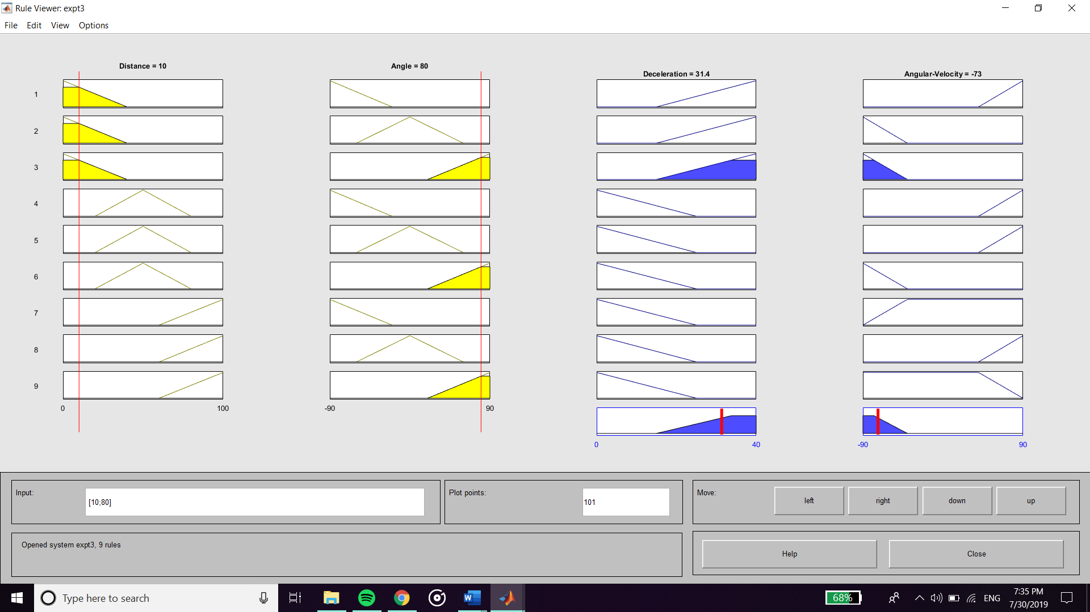

**For Far obstacle and sensed at Center of the vehicle**

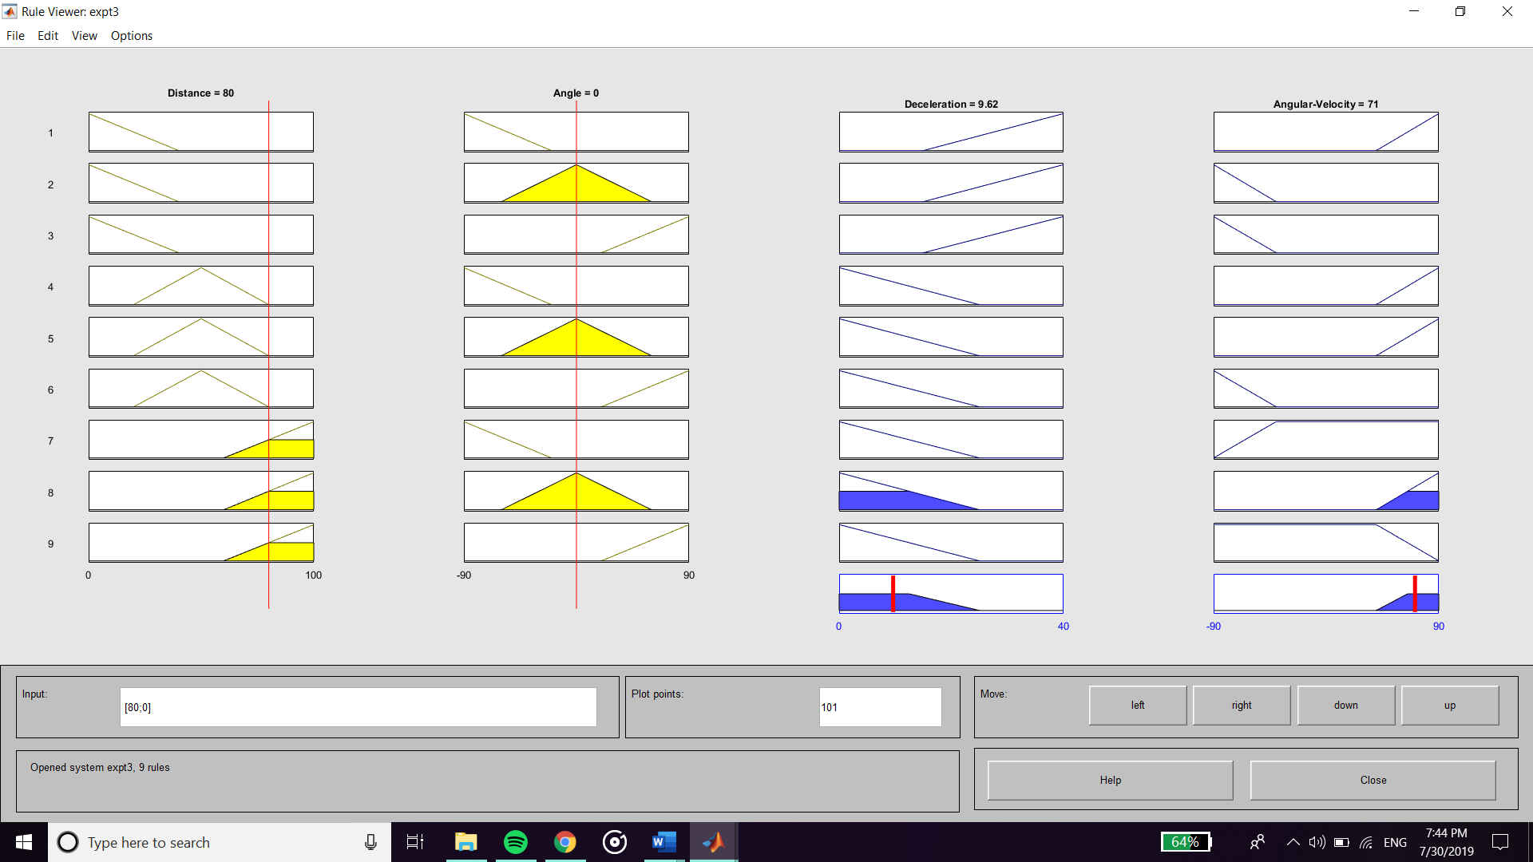

**Surface Viewer**

**Surface for Deceleration**

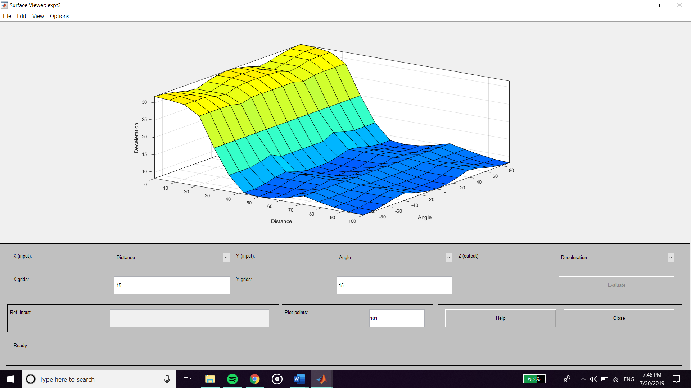

**Surface for Angular Velocity**

